

Vuyani Daweti | EEE1000X | December 1, 2015

Evacuated Tube Solar Collector Microcontroller

USING GBOard pro (arduino)

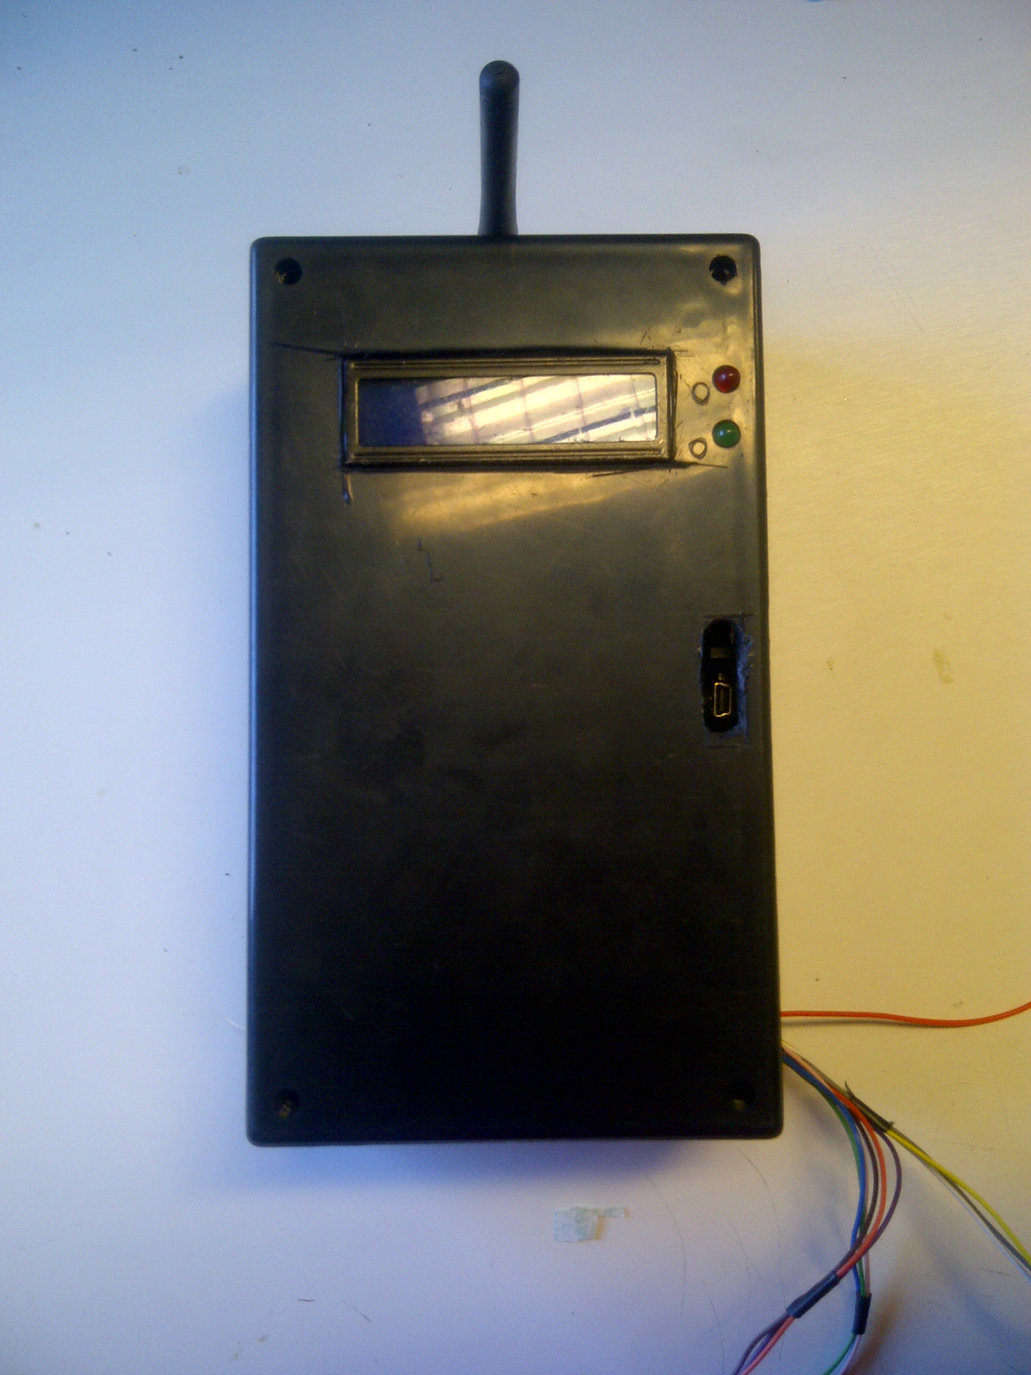

# ABSTRACT

This report serves as a guideline to how the microcontroller of the Evacuated Tube Solar Heater was designed and all the procedures that were followed to the finish of the product.

# CONTENT

1. INTRODUCTION…………………………………………………………………………………………………….…Page 3.
2. FIGURES……………………………………………………………………………………………………………..…......Page5.
3. MICROCONTROLLER DESIGN……………..………………………………………………………….….……Page 7.
   1. CODE…………………………………………..…………………………………………………………..….…….…Page 7.
   2. OUTPUTS AND INPUTS………………..…………………………………………………….….…....……Page 8.
4. RECOMMENDATIONS………………………..…………………………………………………….………..…….Page 9.
   1. An alternative for the relay…………..………………………………………………….……..……………Page 9.
   2. Power Cycling………………………………..……………………………………………….…………………….Page 9.
   3. Time shield……………………………..……..……………………………………………….……………………Page 9.
5. CONCLUSION………………………………………..……………………………………………………….....……..Page10.
6. REFERENCES………………………………………………………………………………………..…………………….Page11.

# 

# INTRODUCTION

In this report we build a microcontroller for an Evacuated Tube Solar Collector that will be used for demonstration to school learners during show cases and other projects. The prototype has been built and it was made possible for other users to easily modify and upgrade.

The Evacuated Tube solar collector is a renewable energy source it uses the sun as the energy source. The thermal energy of the sun is converted to electrical energy through the tubes that are made up of glass layers which are insulated for heat loss. Inside these glass tubes are copper vacuum pipes that absorb the heat and transfer it to the top where copper header pipes are located.These pipes are the ones that water flows through. The heats is then transferred through these header pipes to the water by a concept called zero law of thermodynamics (where two substance at different temperatures share the heat up until they both have same temperature).The place where the header pipes are located is called **manifold.**

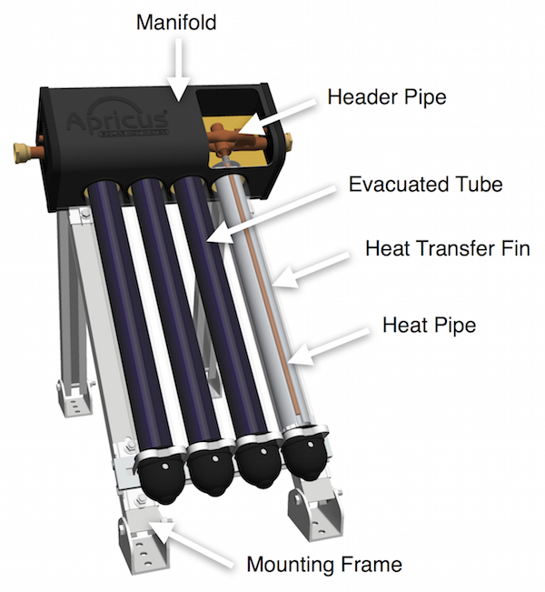

([www.apricus.com/html/solar_collector.htm#.VoEd@usl9dk](http://www.apricus.com/html/solar_collector.htm#.VoEd@usl9dk)) Figure 1.1

The Evacuate Tube Solar Collector is always at work whenever there is sunlight, but for this project we do not want the solar panel to be always heating up water, we want it to heat the water to a certain limit. As a result we are going to design a microcontroller which will monitor the temperature of the tubes and that of the tanks where water will be stored.

The following list are the requirements of the microcontroller design.

* It has to monitor the temperature of the tank to the required level.
* It has to stop circulating water when the desired temperature has been reached.
* There are to be indicators of the pump and water circulation.
* The temperature difference can only fall up to 2 degrees Celsius difference for water to not circulate.

For this design we are going to use Gboard Pro. It is basically an Arduino with Arduino shells.

Specimen:

-supply voltage 7-24V

-Input High voltage VH 3V, 3.3V, 3.6V

-Input low voltage – 0.3; 0; 0.5V

-Average Current consumption 100-500mA

-Peak Current consumption 2A

-ATMega2560 microprocessor

- Interfaces

Xbee

nRF2401

LCD

microSD card

SIM900 communication

For this project will use microSD card and LCD.

For temperature readings we will use thermocouples (LM35DZ).

# FIGURES

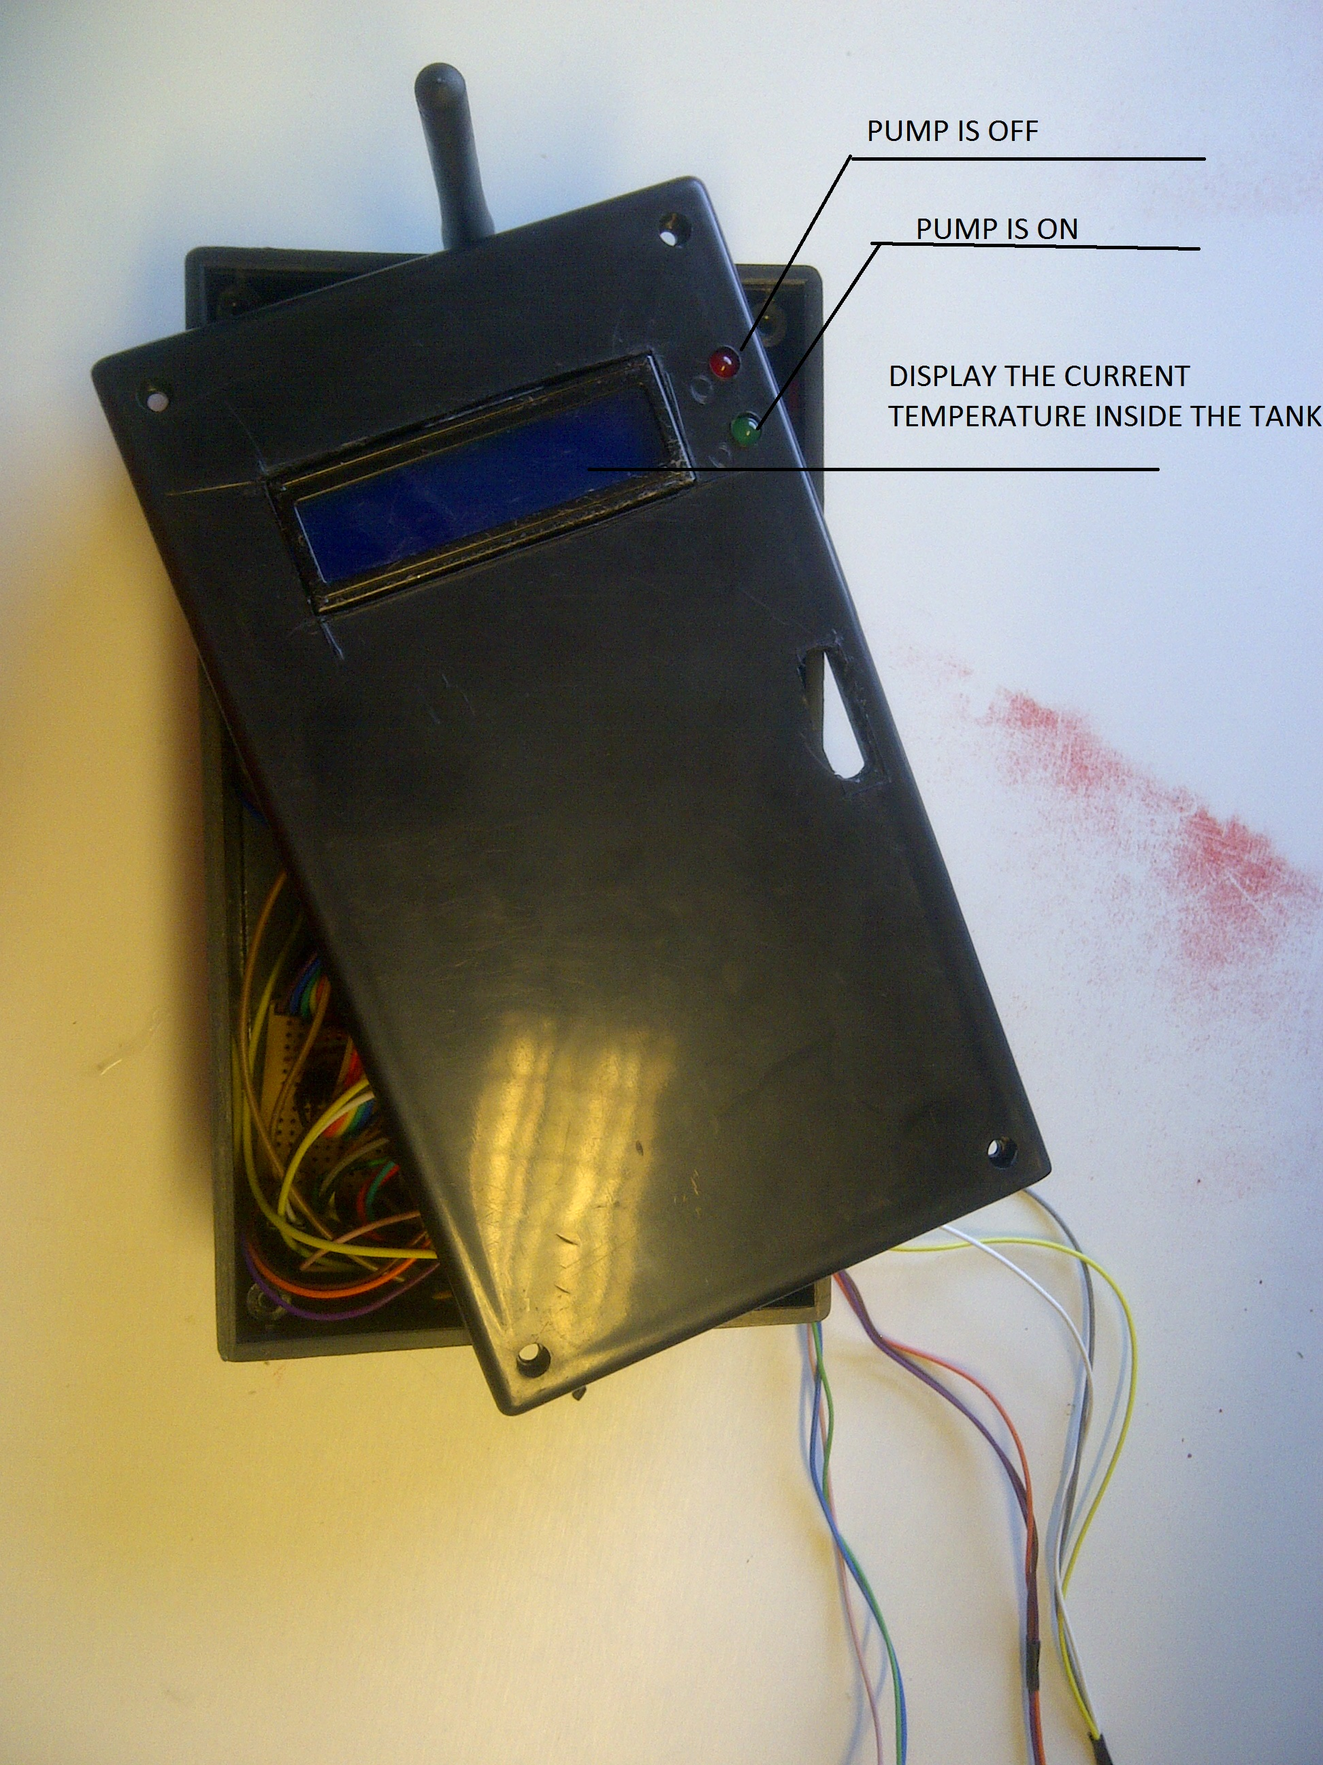 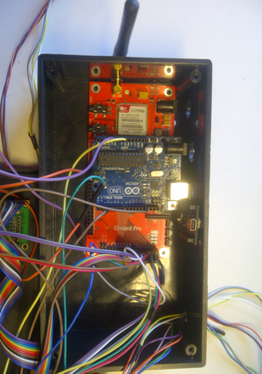

Figure 1.2 Figure 1.3

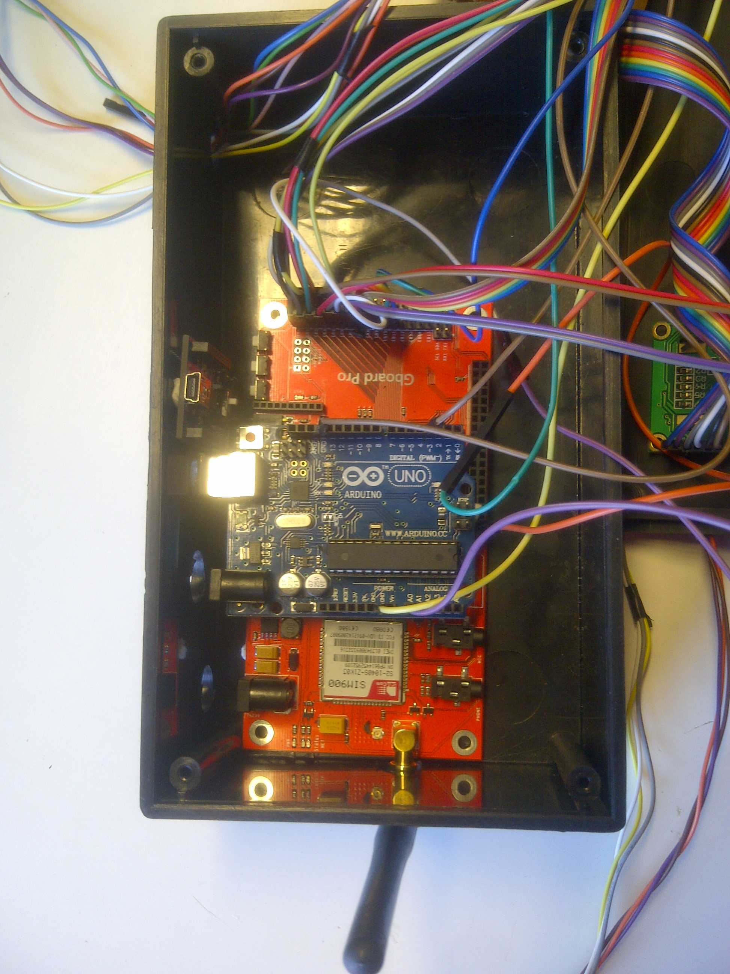 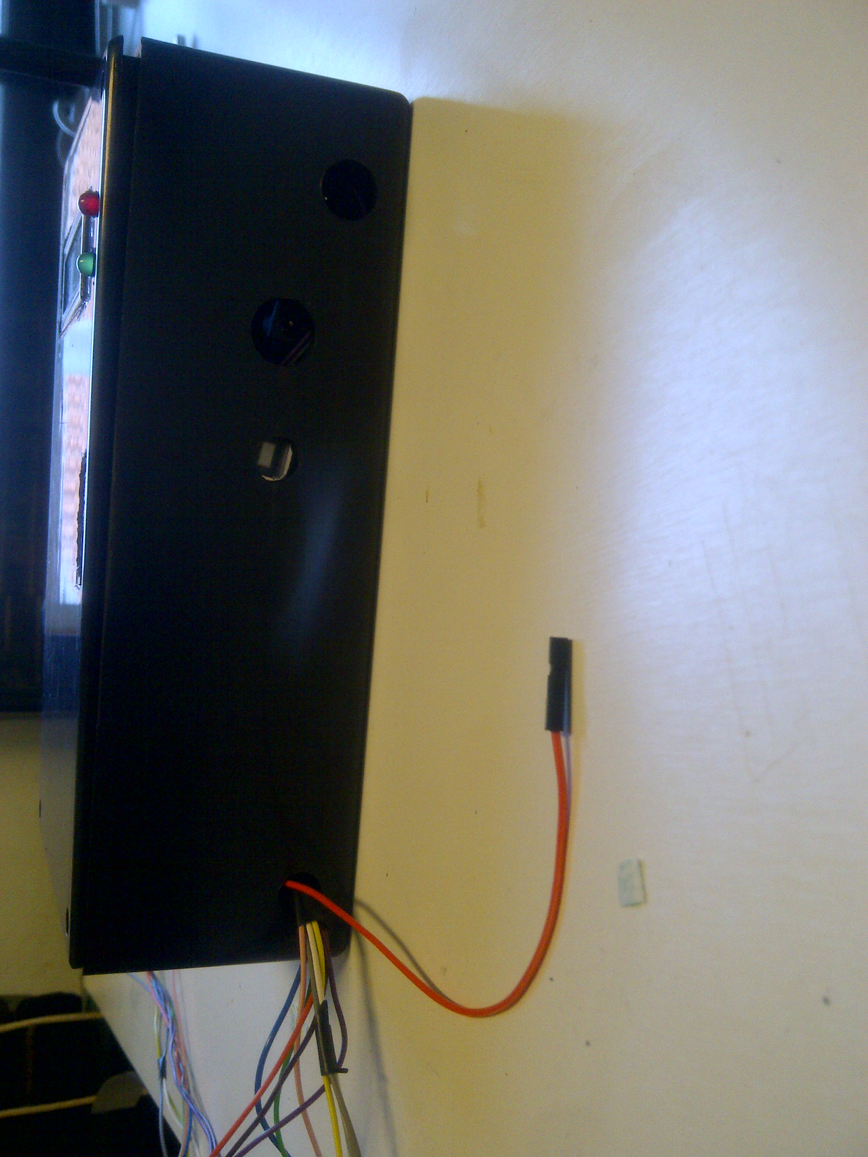

Figure 1.4 Figure 1.5

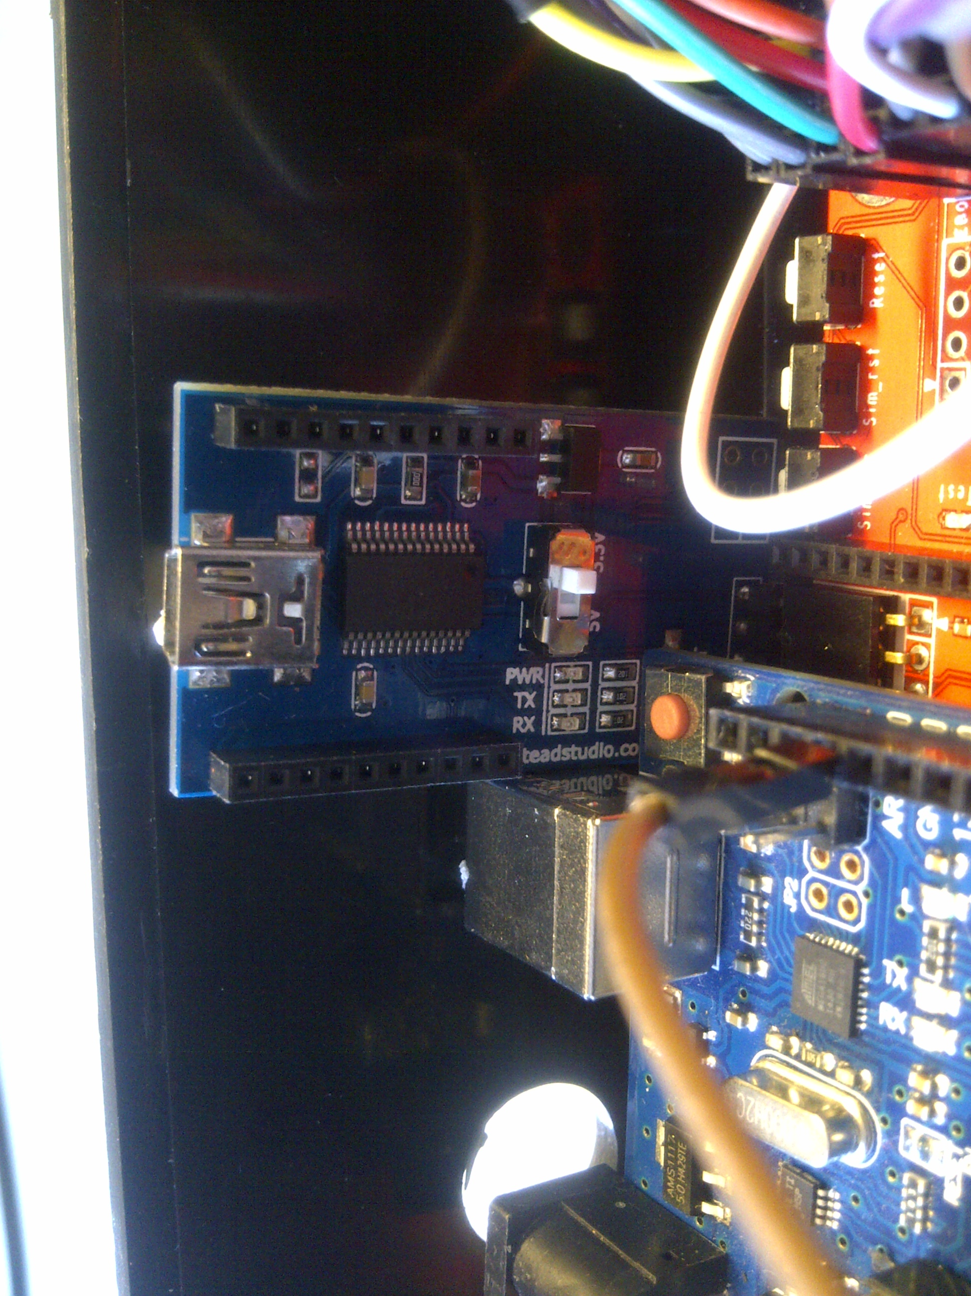 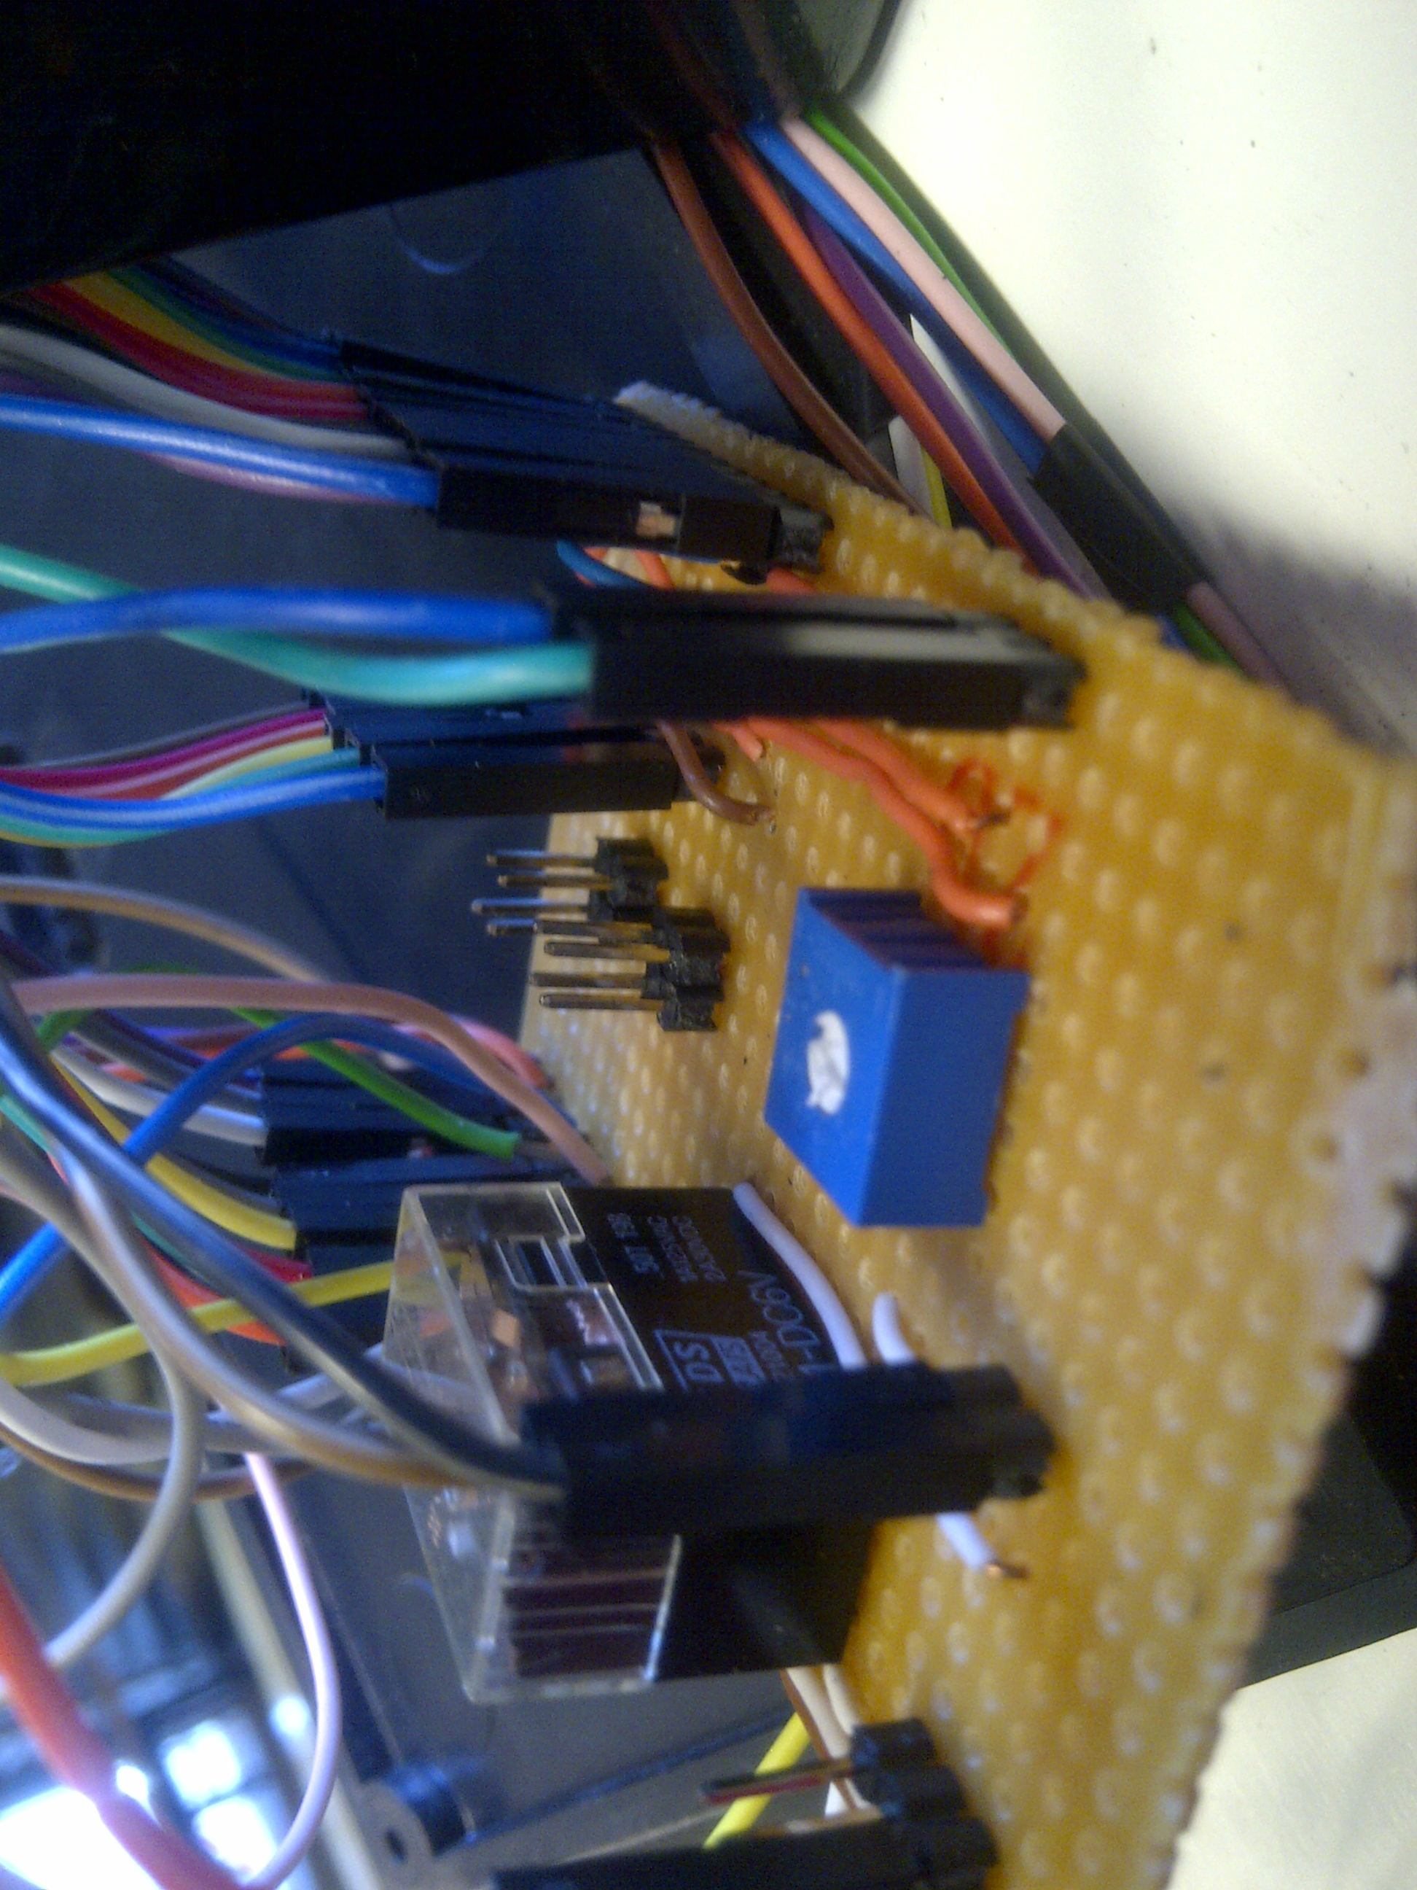

Figure 1.6 Figure 1.7

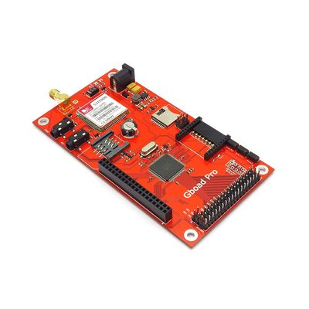 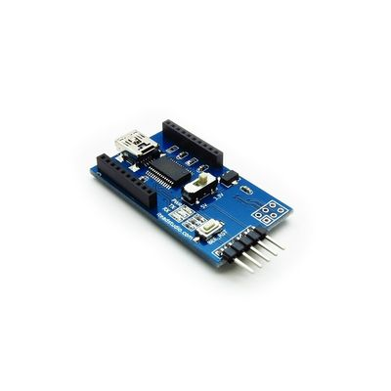

Figure 1.8 the Gboard: Figure 1.9 Foca:wiki.iteadstudio.com/Foca

wiki.iteadstudio.com/image/9/98/Gboardpro.jpg

In figure 1.3 the red board is the Gboard and the Blue board is Arduino Uno.

In figure 1.5 the small board is the FOCA (Figure 1.9) used to upload the code program.

In figure 1.6 is the black box is the relay that controls the pump and the potentiometer is for the LCD screen contrast.

There other figures are fully explained within the report.

1. MICROCONTROLLER

This microcontroller contain ATMega2560 has high performance and operates at a very low voltage of 3.3V, it has 32 general purpose registers which are advantageous for our project. It is also compactible with many of the shield that are included in the board.

3.1 CODE

We used C programming language using the Arduino Software (IDE) for programming the microcontroller which can be loaded from Arduino home site.

The code does the following:

Read the resistance of the LM35DZ and convert it to voltage using 10-bit and 3.3v

(Inlet of manifold, outlet of the manifold and the tank)

Write the voltage to the microSD Card

If (outlet temperature –tank temperature > 2)

NO

YES

Turn ON Red LED

Turn On PUMP

Turn ON Green LED

Display the temperature of the Tank

This code will be executed if only the microSD card is present if not it will wait until the microSD card is inserted. The reading are read every 1 second and stored into the microSD card.

Every time when the program runs (when the microcontroller is turned on) a new file is created and also every 10 mins after it has been initialized a new file is created. The files are stored using millis so that the files don’t rewrite, the file can only be re-written if the program is running again.

# OUTPUTS AND INPUTS

There are four outputs and three inputs.

**Outputs**

LDC screen displays the information according to the running program.

Red LED turns ON if the pump is off.

Green LED turns ON if the pump is operating.

The relay which controls the pump (an Arduino has been used as a regulator).

**Input**

The temperature of the: Tank

Inlet collector

Outlet collector

The relay that we used for the pump draws current that exceeds the available current in the Gboard therefore we used an Arduino Uno since it can give an operating output of 5V with low current, making it suitable for the use of the relay to control the pump.

The LCD screen that we used is a 16x2 dimension with an operational voltage of 5V and light intensity. This made it possible for the data to be displayed even though it is not 100% displayed due to the amount of voltage that our board can provide.

The microcontroller is covered with a plastic cover which is suitable for the weather conditions of the environment. All the components of the microcontroller were fit on the container and openings were made for the plugins as shown in figure 1.4.

# RECOMMENDATIONS

# An alternative for the relay

This project uses a relay to control the pump of which is a problem if we want to keep the temperature at a small variation of temperature. I would recommend a use of voltage variation which will variate the temperature according to the gradient difference for instance, if the gradient is close to 2 the pumping rate should be slow compared to gradient that is far greater than 2.

A MOSFET could be used but the problem is that it will undergo overheating which might be a problem when the pump is suppose function for long periods.

An Arduino shell could be also used but the problem is that is only needs 5V supply of which the board we use only provides 3.3V as an output.

# Power Cycling

The code needs to automatically switch off the system to sleep mode when the sun is not present so that the user does not need to be switching on and off every day. There should be selected times where by the system starts operating and the stop operating. Which would be advantageous for power saving

# TIME SHIELD

There should be a time shield so that when storing files to the memory card the files are stored using date and time making it easier for the user identify the file using date and time at which the file was store in microSD card.

# CONCLUSION

The purpose of this microcontroller to be designed was to make it easy for the user to benefit from the Evacuated Tube Solar Collector with less efforts. This product is environmentally friendly it is much better than using actual electricity since you can easily monitor the system with no fear of electrocution. It is a high recommended product for home consumers as it has long life span that making monthly bills of electricity.

# REFERENCES

1. Wikipedia, Solar_thermal_collector[online]

Available at: e.n.wikipedia.org/wiki/Solar_thermal_collector.[accessed December 1, 2015]

1. Apricus, Evacuated Tube Solar Collector[online]

Available at: [www.apricus.com/html/solar_collar.htm#.VoOOf-sl9dk](http://www.apricus.com/html/solar_collar.htm#.VoOOf-sl9dk)

1. ITEAD Wiki, Gboard Pro[online]

Available at: wiki.iteadstudio.com/Gboard_Pro